1.Create a comparison table listing at least 5 key differences between traditional WAN and SD-WAN, focusing on how data is routed, managed, and secured.
Feature | Traditional WAN | SD-WAN
1. Data Routing | Traffic usually follows fixed, pre-configured routes through routers. | Traffic is dynamically routed based on application needs, network conditions, and policies.
2. Management | Each router/device is configured and managed individually. | Centrally managed using an SD-WAN controller/orchestrator.
3. Path Selection | Usually depends on static routes or traditional routing protocols such as OSPF, EIGRP, or BGP. | Automatically selects the best available path using real-time network conditions.
4. Security | Security often depends on separate firewalls, VPNs, and security appliances at branch locations. | Security policies can be centrally configured, with features such as encryption, segmentation, and integrated security.
5. Internet Usage | Often relies heavily on expensive private WAN connections such as MPLS. | Can intelligently use multiple links such as MPLS, broadband, and 4G/5G.
6. Configuration | Changes may require manual configuration at multiple branch routers. | Policies can be configured centrally and pushed to multiple branches automatically.
7. Application Awareness | Routing is primarily based on IP addresses and routing information. | Can identify applications and prioritize critical traffic, such as VoIP or video conferencing.
8. Scalability | Adding new branches can require significant manual configuration and deployment. | New branches can be deployed more quickly using centralized configuration and automation.

2.Draw a simple network diagram (on paper or using a tool like draw.io) showing how SD-WAN connects multiple branch offices to cloud apps (like Office 365 or AWS) and the main data center. Label the SD-WAN controllers, edges, and at least two types of WAN links (e.g., MPLS, broadband).
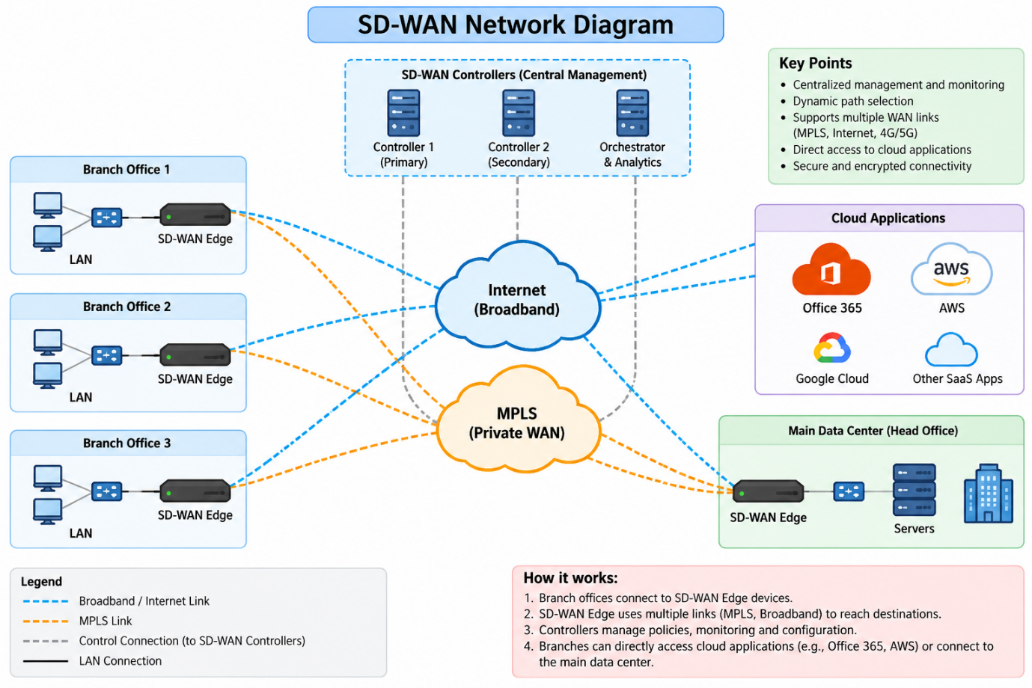

3.Pick any app you use daily (like WhatsApp, Zomato, or Instagram) and write a short scenario explaining how SD-WAN could improve user experience for that app when used across multiple cities in India.<br><br><em><strong>Hint:</strong> Think about speed, reliability, and security when users access the app from different locations.</em>
Scenario: WhatsApp Using SD-WAN Across Multiple Cities in India
Imagine WhatsApp has offices and servers across different cities such as Ahmedabad, Mumbai, Delhi, Bengaluru, and Hyderabad.
Without SD-WAN, network traffic may use a fixed path. If that connection becomes slow or unstable, WhatsApp services for employees in that city may become slower.
With SD-WAN, the company can use multiple WAN connections such as MPLS, broadband, and 4G/5G.
Example: An employee in the Ahmedabad office is using WhatsApp to access company services. If the broadband connection becomes slow, SD-WAN can automatically select a better available path, such as MPLS or another Internet connection.
Benefits
• Speed: SD-WAN can select a better-performing network path.
• Reliability: If one WAN link fails, traffic can use another available link.
• Security: Traffic can be encrypted and security policies can be applied centrally.
• Better user experience: Users in different cities can get more consistent access to applications.
• Centralized management: Network administrators can manage and monitor connections across all cities from one place.

In short: SD-WAN can help an organization provide faster, more reliable, and secure access to applications across multiple Indian cities.
4.List and explain three key benefits of SD-WAN for a company with offices in Ahmedabad, Mumbai, and Bangalore. For each benefit, give a real-world example of how it would help employees or customers.
Benefit | Explanation | Real-world example
1. Better Speed & Performance | SD-WAN automatically chooses the best available network path based on network conditions and application requirements. | Employees in the Ahmedabad office are using Microsoft Teams for a video meeting with the Bangalore team. If one Internet link is slow, SD-WAN can route the traffic through a better link, reducing lag and interruptions.
2. High Reliability & Automatic Failover | SD-WAN can use multiple WAN connections such as MPLS, broadband, and 4G/5G. If one link fails, traffic can move to another available link. | The Mumbai office's broadband connection fails during an important customer transaction. SD-WAN automatically switches traffic to the backup MPLS/4G connection, allowing employees to continue working.
3. Centralized Security & Management | Network administrators can manage routing and security policies for all offices from a central SD-WAN platform. | The company can apply the same security policy to Ahmedabad, Mumbai, and Bangalore. Administrators can monitor all three offices centrally instead of configuring every router separately.

